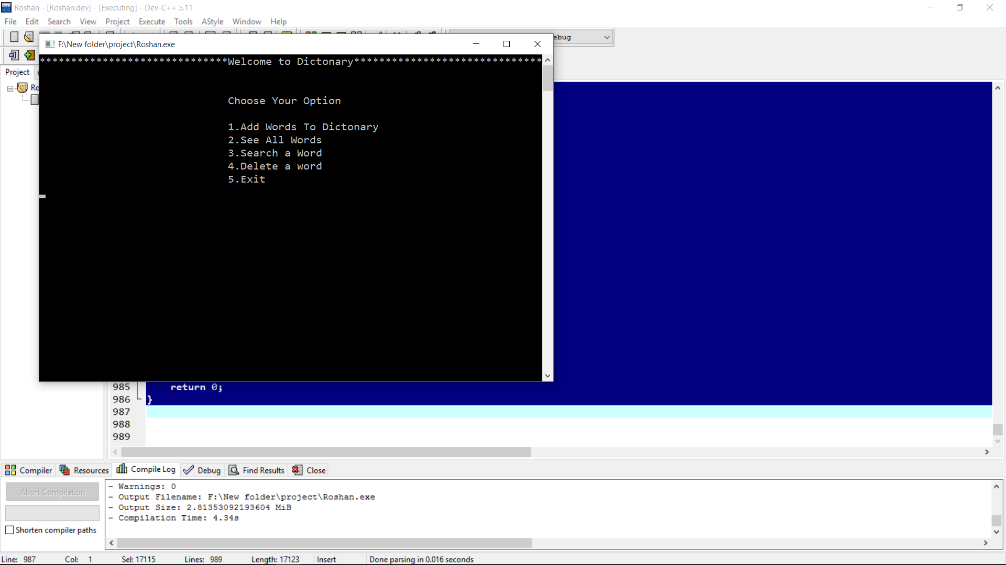

Fig:1.1 Main Menu

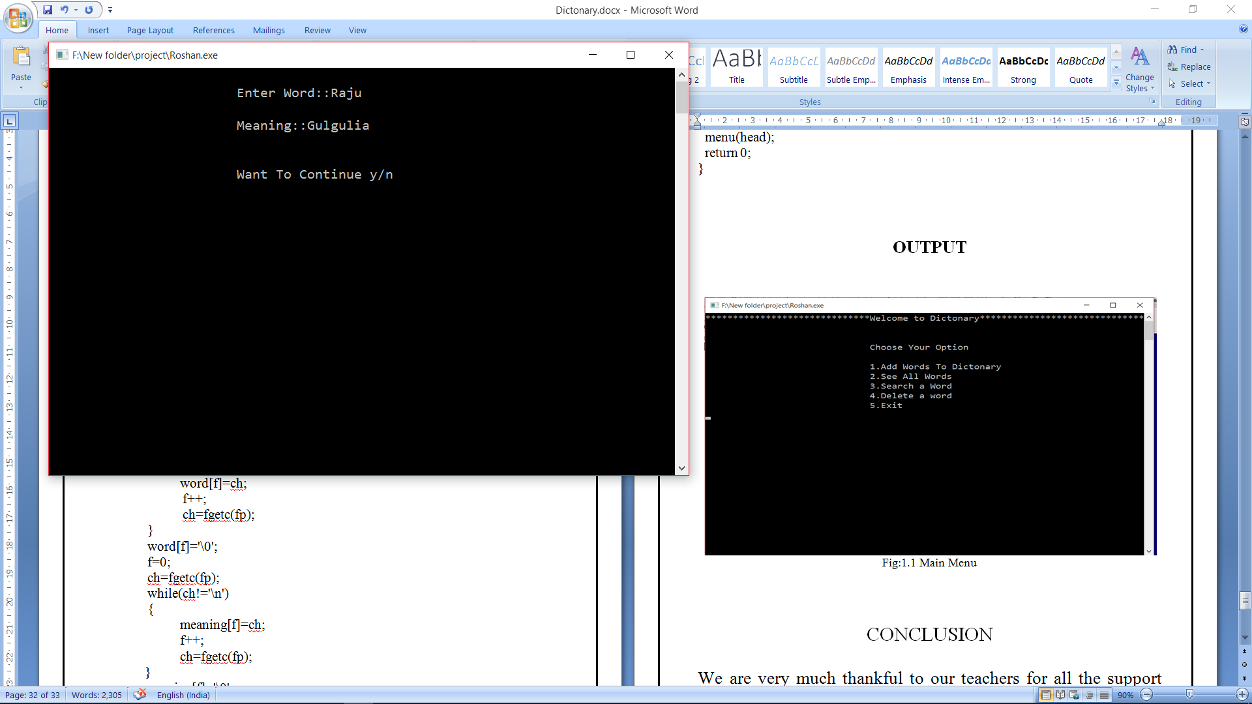

Fig:1.2 Adding Words

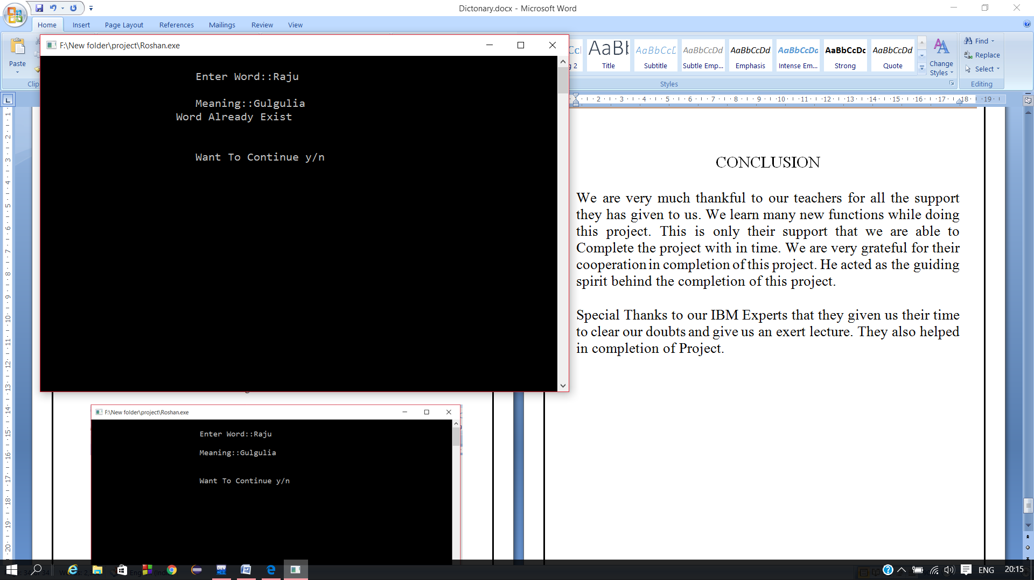

Fig:1.3 Duplicate Word is not possible

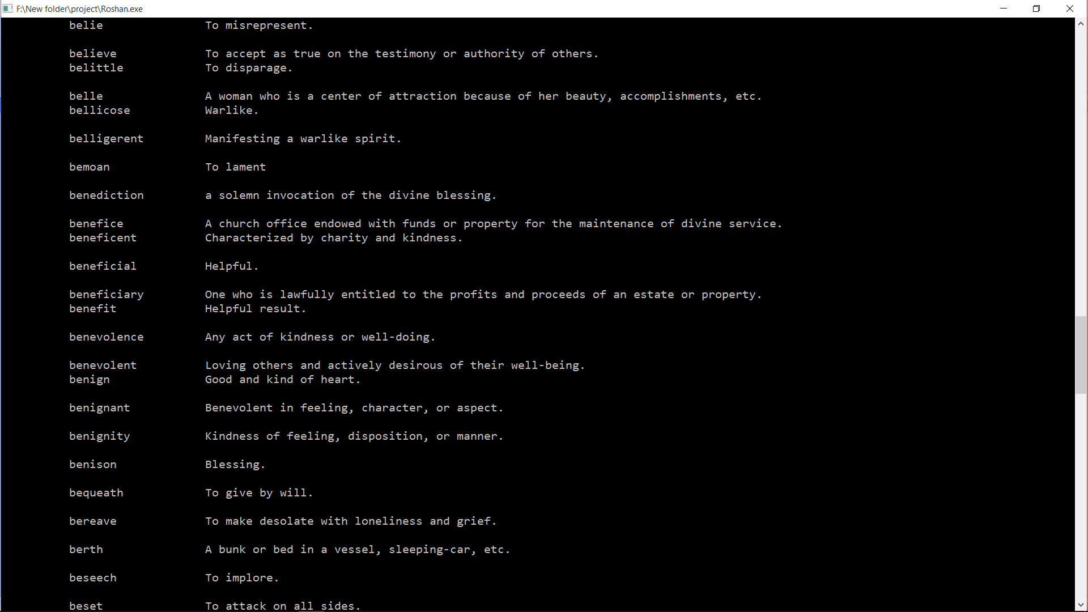

Fig: See All Words

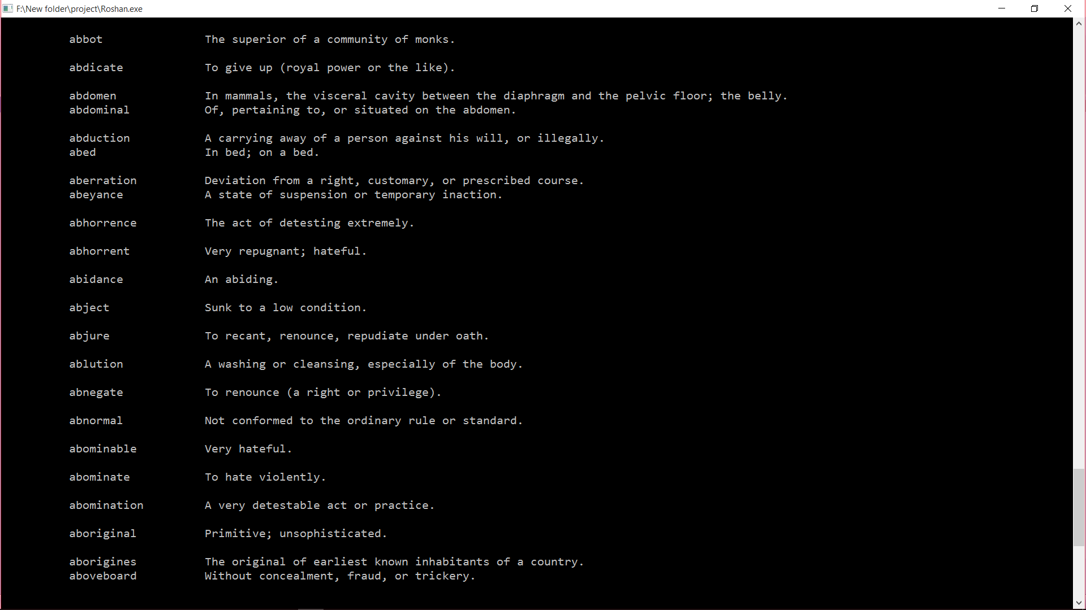

Fig:1.5 Words Starting with A

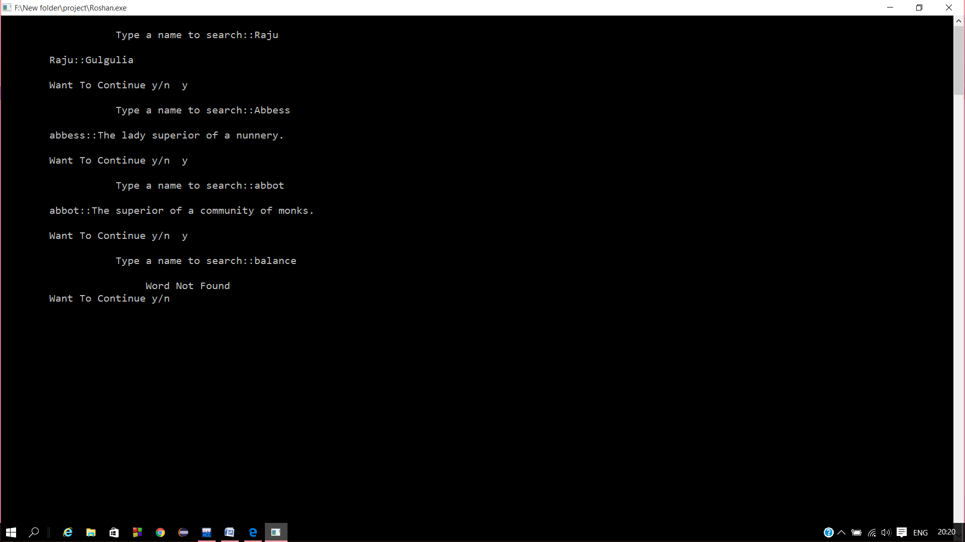.

Fig:1.6 searching Words

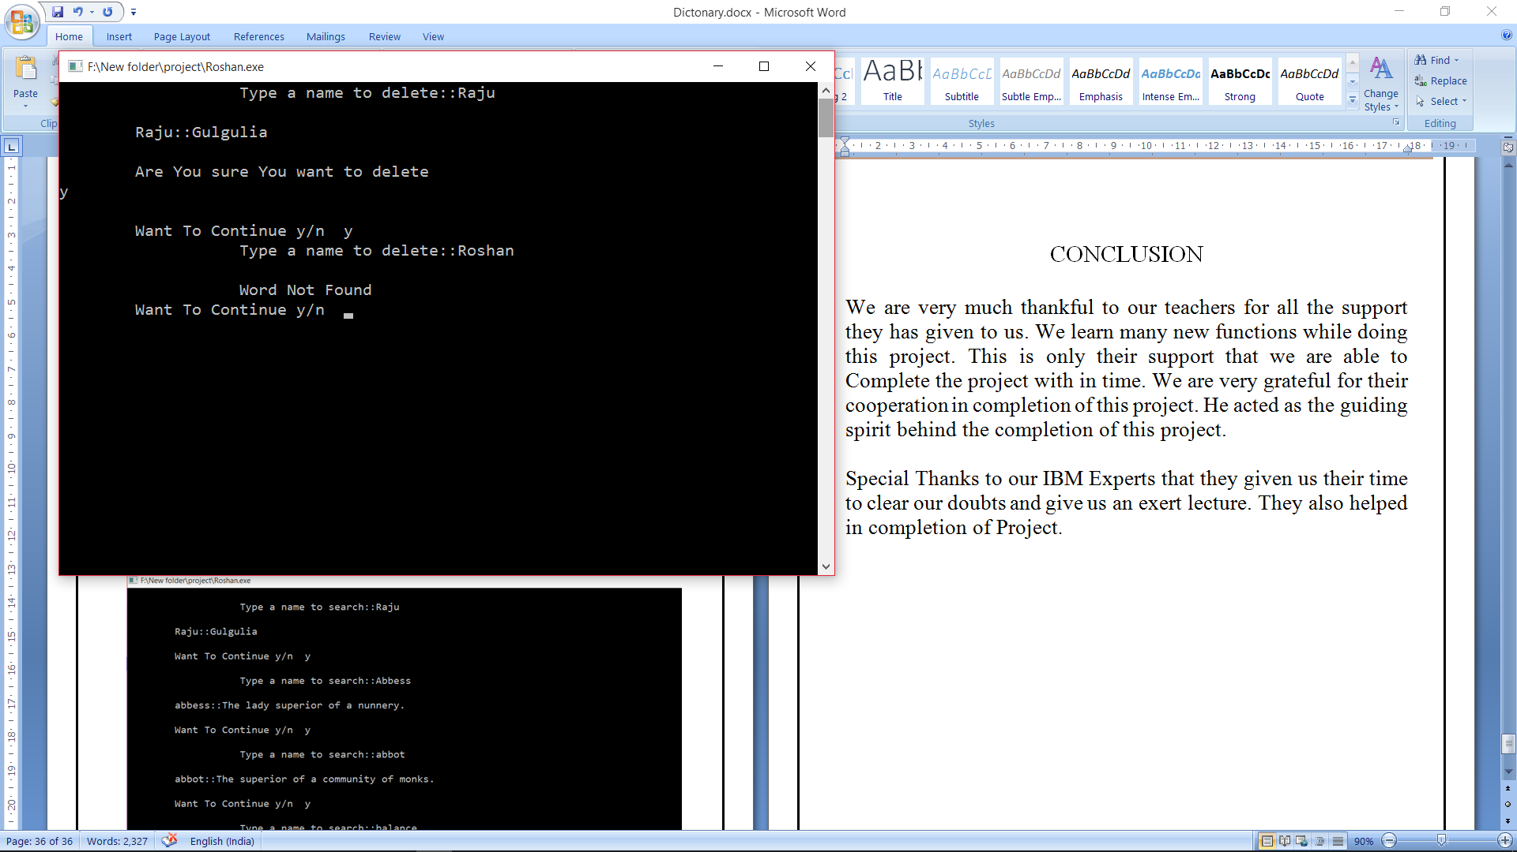

Fig:1.7 Delete a word

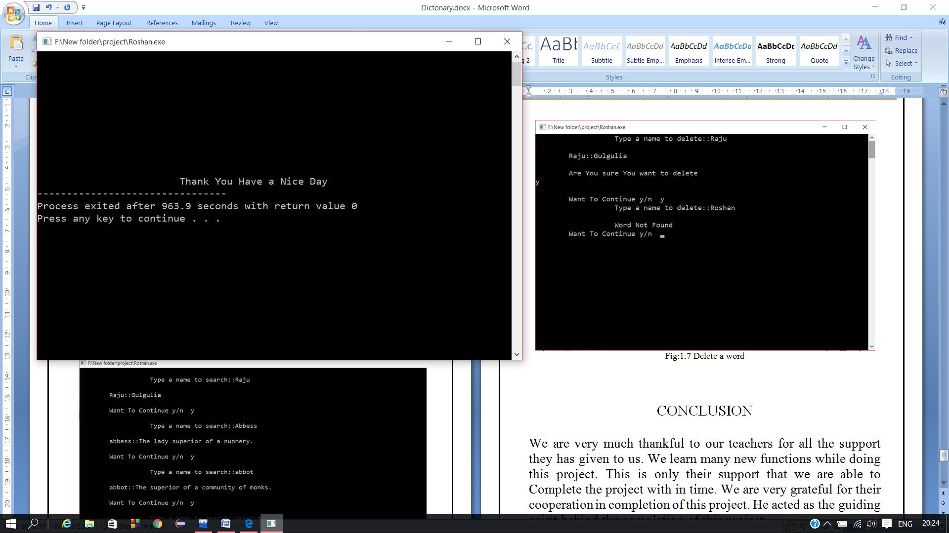

Fig:1.8 Exit

CONCLUSION

We are very much thankful to our teachers for all the support they has given to us. We learn many new functions while doing this project. This is only their support that we are able to Complete the project with in time. We are very grateful for their cooperation in completion of this project. He acted as the guiding spirit behind the completion of this project.

Special Thanks to our IBM Experts that they given us their time to clear our doubts and give us an exert lecture. They also helped in completion of Project.